

**Quality Assurance for Reform and Transformation of HEIs in Uzbekistan - QUARTZ**

Call: ERASMUS-EDU-2023-CBHE-STRAND-1 /

Project Number: 101127171

Dissemination level: all partners

**RETRAINING MINUTES**

**at Urgench Branch of Tashkent University of Information Technologies**

**Venue: Tashkent University of Information Technologies named after Muhammad Al-Khorazmi, Urgench Branch**

**Address: Al-Khorazmi Street, 110, Urgench, Uzbekistan**

**Location: Urgench Branch of TUIT**

**22-23 May 2025**

**Re-training Minutes**

**Program:** Quality Assurance for Reform and Transformation of HEIs in Uzbekistan (QUARTZ)  
**Venue:** Urgench Branch of Tashkent University of Information Technologies (UBTUIT)  
**Dates:** 22–23 May 2025  
**Theme:** *The Main Principles for an Effective Quality Assurance Policy*  
**Topic:** *Planning and Implementing a QA Strategy*

**1. Objectives of the Retraining**

The main purpose of the QUARTZ retraining was to strengthen knowledge and skills in quality assurance systems within higher education institutions in Uzbekistan, incorporating European experience. The program focused on:

* Defining and formalizing a coherent vision of quality in teaching, research, and institutional management.
* Developing practical skills for planning, implementing, and assessing QA strategies.
* Fostering collaboration and exchange of best practices among participating institutions.

**2. Program Overview**

The retraining lasted two days and combined lectures, discussions, and group exercises. It was held at the Videoconference Hall 102, UBTUIT Urgench branch.

**Day 1:**

* *Welcome & Opening Remarks* by Director Shukurulloh Ismoilov.
* *Lecture 1:* Review of the University’s Quality Governance and Assurance System (Zafarbek Madrakhimov).
* *Lecture 2:* Introduction to Quality Assurance in the European Context (Nafisa Erimmetova).
* *Lecture 3:* Planning the Academic Offer (Shokhidakhon Abdullaeva).
* Discussion, Q&A, and practical group exercises.

**Day 2:**

* *Lecture 1:* Strategic Planning of Research Structures and Assessment Criteria for PhD Programs (Oybek Allamov).
* *Lecture 2:* Lifelong Learning (Nafisa Erimmetova).
* *Lecture 3:* Student-Centered Curricula and PhD Design (Zafarbek Madrakhimov).
* Discussion, Q&A, and applied exercises.

### 3.Key Outcomes and Learning Achievements

Participation in the QUARTZ retraining program produced a wide range of tangible and intangible outcomes for both individual participants and the institution as a whole. Over the course of the two intensive days, we were able to deepen our understanding of how a modern, effective quality assurance (QA) system should function within a higher education institution. In particular, the sessions clarified the importance of moving from fragmented or informal practices toward a clearly defined and formalized policy framework. Participants learned how European universities structure their QA systems to ensure transparency, consistency, and continual improvement across teaching, research, third-mission activities, and institutional governance.

Another major achievement was the opportunity to examine, in detail, the processes of planning and implementing a QA strategy that aligns institutional goals with national and international standards. Lectures and case examples highlighted how to develop assessment criteria for academic programs, doctoral research structures, and staff development, as well as how to integrate mechanisms for regular evaluation and feedback. This helped participants appreciate not only the technical aspects of QA (such as indicators, benchmarks, and reporting) but also the cultural and organizational shifts required to make quality processes part of everyday academic life.

The retraining also emphasized the design of student-centered curricula and the concept of lifelong learning, which are increasingly central to European higher education. By working through group exercises and discussions, we explored how to create academic offerings that respond to student needs, labor-market trends, and societal priorities, while maintaining rigorous academic standards. These activities strengthened our ability to translate abstract QA principles into practical tools such as program learning outcomes, evaluation rubrics, and continuous improvement cycles.

### Conclusion

The QUARTZ retraining in Urgench on 22–23 May 2025 was very useful for all participants. During two days we learned about modern quality assurance practices, European experience and how to plan and improve our own university’s QA system. We also practiced new skills in group exercises and exchanged ideas with colleagues from other institutions.

This training helped us to better understand how to develop student-centered programs, improve PhD planning and assessment, and introduce lifelong learning principles. We will share the knowledge gained with our colleagues and use it to strengthen our university’s internal quality assurance processes.

Overall, the retraining achieved its goals and gave us practical tools and motivation to continue improving the quality of education and management at our institution.

**Pictures from the re-training**

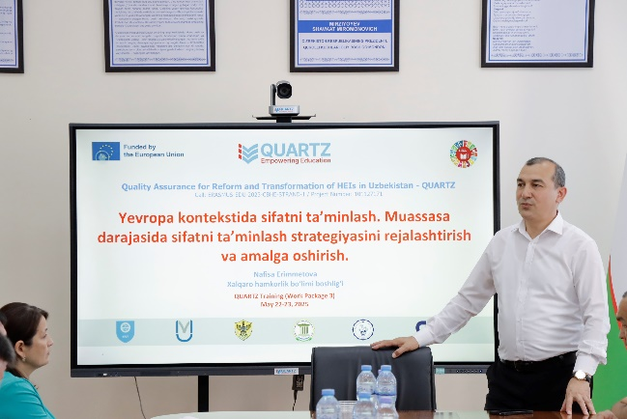 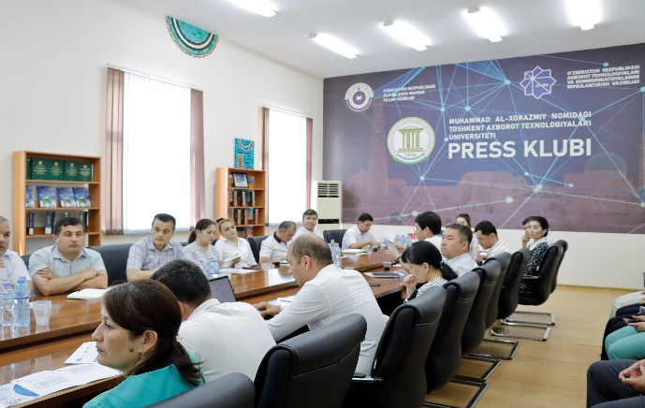

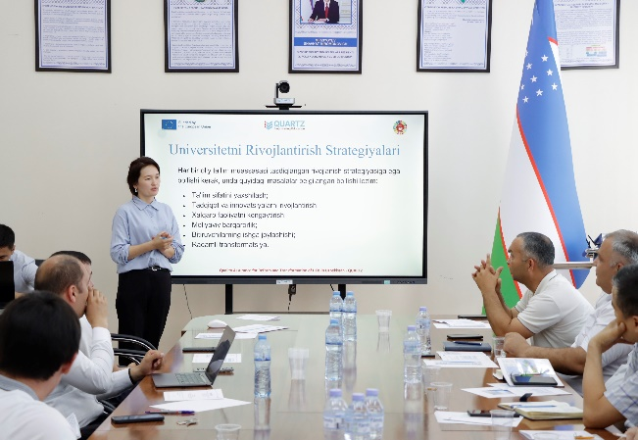 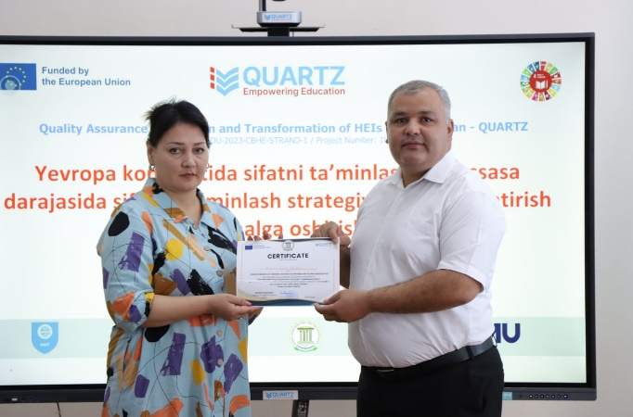

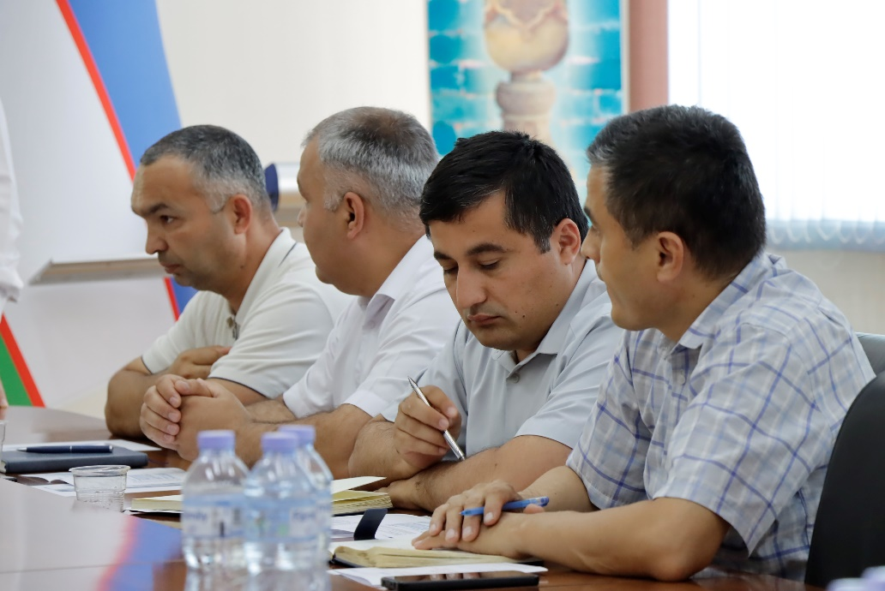

**Links to more details:** [**https://t.me/UBTUIT_official/20277**](https://t.me/UBTUIT_official/20277)**;** [**https://t.me/UBTUIT_official/20303**](https://t.me/UBTUIT_official/20303)**;** [**https://t.me/UBTUIT_official/20351**](https://t.me/UBTUIT_official/20351)